CONTACT: Nancy Richards – 917-873-6389 (cell) /nancy@northcoastrep.org
MEDIA PAGE: www.northcoastrep.org/press
FOR IMMEDIATE RELEASE, PLEASE:

JEALOUSY, FAMILY TENSIONS ERUPT
DURING THE HOMECOMING
AT NORTH COAST REPERTORY THEATRE
By Harold Pinter
Performances Beginning Wednesday, March 2, 2022
Running Through Sunday, March 27, 2022
Directed by David Ellenstein

Solana Beach, Calif. – THE HOMECOMING is often regarded by critics as Nobel Laureate Harold Pinter’s most enduring play. Set in an all-male household that relies on fantasy and one-upmanship for its very existence, it is a searing masterwork of family warfare. The family’s toxic, but familiar pattern is disrupted by the arrival of a long-absent son and his new wife. Her presence ignites an explosive situation, one that is vicious, funny and unsettling. Although written more than 50 years ago, the play explores issues about power, sexuality and self-identity that are still debated today. This Tony winner for Best Play is must-see theatre for the serious playgoer. Directed by David Ellenstein. For mature audiences only.

David Ellenstein directs Frank Corrado*, Richard Baird*, James Newcomb*, Justin Gordon*, Bruce Turk*, and Melanie Lora* in THE HOMECOMING. The design team includes Marty Burnett (Resident Scenic Designer), Matthew Novotny (Lighting), Elisa Benzoni (Costumes), Philip Korth (Props), & Victoria Hanlin (Dialect Coach). Christopher M. Williams* Rehearsal Stage Manager and Aaron Rumley* Performance is the Stage Manager.
*The actor or stage manager appears through the courtesy of Actors’ Equity Association. For photos, go to www.northcoastrep.org/press.

THE HOMECOMING previews begin Wednesday, March 2nd. Opening Night on Saturday, March 5, at 8pm. There will be a special talkback on Friday, March 11, with the cast and artistic director. It will play Wednesdays at 7pm, Thursdays through Saturdays at 8pm, Saturday and Sunday matinees at 2pm with Sundays at 7pm through March 27. (See Schedule below). North Coast Repertory Theatre is located at 987 Lomas Santa Fe Drive, Solana Beach, CA 92075. Tickets: Previews - $54 (including Friday preview at 2pm), Week Nights/Wed. & Sat. Matinees - $60; Sat. Eve. & Sun. Mat. $65; Sun Night - $57. Seniors, Students, Military & Educators - $3 off admission. Call 858-481-1055, or visit www.northcoastrep.org to purchase tickets.

FACT SHEET:

WHAT: NORTH COAST REPERTORY THEATRE presents
THE HOMECOMING
By Harold Pinter
Directed by David Ellenstein

CAST: Frank Corrado*, Richard Baird*, James Newcomb*, Justin Gordon*, Bruce Turk*, and Melanie Lora*

WHERE: North Coast Repertory Theatre
987 Lomas Santa Fe Drive
Solana Beach, CA 92075

SCHEDULE: Previews start March 2, 2022
Opens: March 5, 2022
Closes: March 27, 2022
Wed. @ 7pm, Thurs-Sat @ 8PM; Sat & Sun @ 2PM, Sun @ 7pm
Fri (March 4) @2pm
Wed (March 23) @ 2pm

PRICES: Previews $54.00
Week Nights & Sat. Matinees $60.00
Sat. Nights & Sunday Matinees $65.00
Sunday Nights $57.00

DISCOUNTS: Seniors, Students, Military & Educators $3.00 off admission. Rush tickets available for $20. 15 minutes prior to showtime
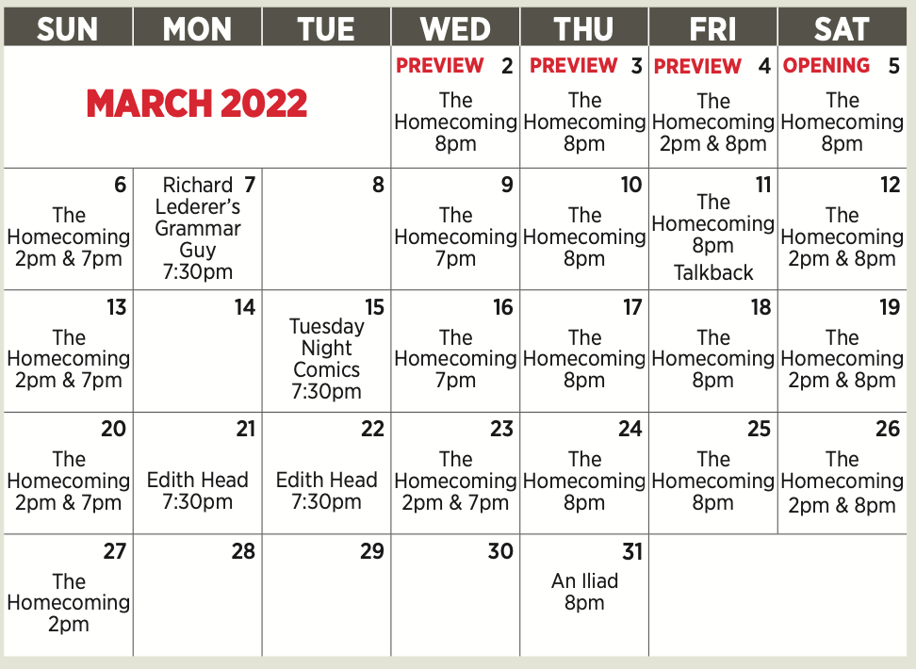

BIOS:
HAROLD PINTER (Playwright) was born in London in 1930 and died on Christmas Eve, 2008. He was married to Antonia Fraser. He wrote twenty-nine plays including The Birthday Party, The Caretaker, The Homecoming, and Betrayal, twenty-one screenplays including The Servant, The Go-Between, The French Lieutenant's Woman and Sleuth, and directed twenty-seven theatre productions, including James Joyce's Exiles, David Mamet's Oleanna, seven plays by Simon Gray and many of his own plays including his last, Celebration, paired with his first, The Room at The Almeida Theatre, London in the spring of 2000. In 2005 he received the Nobel Prize for Literature. Other awards include the Companion of Honour for services to Literature, the Legion D’Honneur, the Laurence Olivier Award and the Moliere D'Honneur for lifetime achievement. In 1999 he was made a Companion of Literature by the Royal Society of Literature. He received honorary degrees from eighteen universities.

DAVID ELLENSTEIN (Director) Born into a theatrical family, David has worked in theatres across the country. Before joining North Coast Rep in 2003 he served as Artistic Director for the Los Angeles Repertory Company and the Arizona Jewish Theatre Company (AJTC). A veteran of over 300 theatrical productions, directorial favorites include: North Coast Rep – Ben Butler, The Outsider, Holmes & Watson, A Funny Thing Happened on the Way to the Forum, The Father, Travels with My Aunt, The Illusion, Way Downriver; William Faulkner’s ‘Old Man’ (West Coast Premiere), Freud’s Last Session (San Diego Premiere), Faded Glory (World Premiere), Mandate Memories (World Premiere), Becoming Cuba (World Premiere), Time Stands Still, Words by: Ira Gershwin and the Great American Songbook (World Premiere), My Name is Asher Lev, The Drawer Boy, Becky’s New Car, Ghosts, The Tempest, Talley’s Folly, Over the Tavern, Old Wicked Songs, The Dresser, Rashomon, A Moon for the Misbegotten; Tuesdays With Morrie; Collected Stories; Halpern and Johnson; Romeo and Juliet; Amy’s View; Einstein Comes Through (also co-author); The Chosen; and A Life in the Theatre. Coconut Grove Playhouse - Sonia Flew starring Lucie Arnaz; Halpern and Johnson starring Hal Linden and Brian Murray. Papermill Playhouse - The Chosen starring Theodore Bikel and John Lloyd Young. 59E59 - His Royal Hipness Lord Buckley. Park Square & Colony Theatre – Words By. Portland Stage - Halpern and Johnson. Renaissance Theatre - Long Day’s Journey Into Night. Actor’s Theatre of Phoenix - Rabbit Hole. Alabama Shakespeare Festival - The Glass Menagerie, Rocket City (World Premiere) and Honky-Tonk Angels. Laguna Playhouse - Chapatti, Alexandros (World Premiere). Southwest Shakespeare Company - Cyrano de Bergerac. AJTC - Awake and Sing. Meadow Brook Theatre - A Christmas Carol. Portland Rep - Conversations With My Father and Gaslamp Quarter Theatre - A Shayna Maidel. Winner of numerous theatre awards, including the San Diego Theatre Critics Circle Award for “2018 Director of the Year.” Favorite roles as an actor include Andrey Botvinnik in A Walk in the Woods, Max Prince in Laughter on the 23rd Floor, at North Coast Rep, title roles in Hamlet at Los Angeles Theatre Center and Los Angeles Repertory Company; Tevye in Fiddler on the Roof at Moonlight Stage, and Richard III at California Shakespeare Festival; David has also been guest faculty for numerous universities including California State Northridge, Cal Arts, and Shakespeare workshops privately.

FRANK CORRADO* (Max) has worked in the theatre primarily as an actor, but also as a director, producer, curator, and playwright, for well over forty years. Much of that time he resided in Seattle, playing major roles in various venues there, as well as making frequent appearancesat theatres across the country. He has acted a number of times at North Coast Rep in productions of Madagascar, The Dumb Waiter, and The Drawer Boy, all directed by his good friend David Ellenstein, as well as serving as director of Betrayal. Although his career has spanned the literature from the Greeks to Shakespeare to Molière to Shaw to the moderns and contemporaries, he has enjoyed a special focus on the plays of Harold Pinter. Shortly after the playwright’s death in 2008, he created and produced a series of readings at A Contemporary Theatre (ACT) in Seattle that, over the course of three years and twenty-five evenings, presented virtually all of Pinter’s works to an ever-growing and enthusiastic audience. The series culminated in 2012 in a festival at ACT with full productions of a number of the plays. Largely in recognition of his adventures in Pinterland, he was awarded the William and Eva Fox Foundation Fellowship for Distinguished Achievement. He presently lives in Off-The- Beaten-Path, New Hampshire with his wife and best friend Mary Hubbard.

RICHARD BAIRD* (Lenny) is an award-winning actor, director, and producer. Productions at North Coast Rep include: Ben Butler, An Iliad, Gabriel, The Father, Around the World in Eighty Days, Travels with My Aunt, Way Downriver, William Faulkner’s ‘Old Man,’ Betrayal, The Dumb Waiter, The Lover, Ghosts, and many more. At NCRT he has directed Dancing Lessons, Amadeus, A Walk in the Woods, and Of Mice and Men. Richard is the Founding Artistic Director of New Fortune Theatre Company where he has directed and appeared in Henry the Fifth (Craig Noel San Diego Critics Circle awards for Outstanding Direction and Lead Performance), The Birthday Party (McCann), and Les Liaisons Dangereuses (co director/ Valmont). Richard has appeared in regional theatres across the country, including The Old Globe, Backyard Renaissance, Santa Barbara Theatre Ensemble, San Diego Rep, Oregon Shakespeare Festival, Chicago Shakespeare Theatre, Portland Centre Stage, Shakespeare Santa Cruz, Arizona Theatre Company, Southwest Shakespeare Company (AriZoni Best Actor for Cyrano de Bergerac), Kingsmen Shakespeare and has directed for Intrepid Theatre and Diversionary Theatre. In memory of Henry Woolf (1930-2021).
JAMES NEWCOMB* (Sam) North Coast Rep: A Christmas Carol (As Told By One Man To Whom It Matters) — Streamed, How the Other Half Loves. The Old Globe: Twelfth Night, Coriolanus, and Much Ado About Nothing. San Diego Rep: Honky, Zoot Suit, Brooklyn Boy, Tommy, and The Illusion. Other Theatres: Oregon Shakespeare Festival: (14 Seasons, and resident Fight Director) Denver Center Theatre, The Public Theatre, B.A.M., Utah Shakespeare Theatre, Shakespeare & Company (founding member), The Goodman, Chicago Shakespeare, Berkeley Rep., South Coast Rep, Shakespeare Santa Cruz, Portland Center Stage, and Geva Theatre. T.V.: “Honky” (P.B.S.), “I Want To Keep My Baby” (CBS),“The Cradle Will Fall” (CBS). Fight Direction: La Jolla Playhouse, The Old Globe, San Diego Repertory Theatre, Chicago Shakespeare Theatre, and many more. Continuing Lecturer and Stage Fight Instructor, UCSD Graduate Theatre Program. Denver Critics Award Orphans (D.C.T.C.), Drama Log Award (SSC), Oxford Society Award (OSF) for Richard III, Craig Noel Award Recipient for Angels In America at Cygnet Theatre.
JUSTIN GORDON* (Joey) is an actor and director based in the Bay Area, and is pleased to make his North Coast Rep debut. Training: Shakespeare’s Globe, London; The University of Illinois at Urbana-Champaign (M.F.A., Acting). Recent credits: Pacific Repertory Theatre—Chicago (Mary Sunshine), Shakespeare in Love (Wessex), Pericles (Pericles), Antonyand Cleopatra (Caesar), and King Lear (Edmund). Additional selected credits: San Jose Stage Company (The Postman Always Rings Twice, world premiere), Utah Shakespeare Festival (Othello, The Two Gentlemen of Verona, Lend Me a Tenor: The Musical, Coriolanus), Rogue Music Theatre (Into the Woods), Cornerstone Theater (On Caring for the Beast), LA Theatre Ensemble (The Comedy of Errors), REDCAT (The 50 Year Sword), The Krannert Center (Hamlet) and freeFall Theatre Company (The Normal Heart). Film and television: “Absentia,” “Oculus,” “Before I Wake,” “Gehenna,” and the Amazon Prime series, “Age of the Living Dead.” Justin is also the Artistic Director of New Canon Theatre Company in Monterey, CA, and a proud member of AEA, SAG-AFTRA, and SDC.
BRUCE TURK* (Teddy) North Coast Rep: Ben Butler, Same Time Next Year, Faded Glory, Freud’s Last Session, Hedda Gabler, At This Evening’s Performance, Now You See It (Director) and has performed On and Off Broadway, internationally, and at major regional theatres across the country. He has been a resident member of Tadashi Suzuki’s Acting Company in Japan, a Resident Artist at Hartford Stage, and a recipient of the TCG/Fox Fellowship for Distinguished Achievement. San Diego audiences have seen his work in fifteen productions of Shakespeare at the Old Globe Theatre, where he received the San Diego Critics’ Craig Noel Award for Leontes in The Winter’s Tale. Other credits include seasons and productions at American Conservatory Theatre, Pasadena Playhouse, Seattle Repertory, McCarter Theatre, La Jolla Playhouse, The Denver Center, The Cincinnati Playhouse, The Goodman Theatre, The Shakespeare Theaters in DC, New Jersey, and Santa Cruz, and many more. Screen credits include “Murder in the First,” “NUMB3RS,” “ER,” “L&O:SVU,” and “Third Watch.” He is a graduate of Northwestern University.
MELANIE LORA* (Ruth) is making her North Coast Rep debut after
a recent move from LA to North County. She has performed in theatres all over Southern California, most recently in Pinter’s The Hothouse at the Antaeus Company. Other roles include: Jess in the world premiere of Of Good Stock at South Coast Rep, Hypatia in Misalliance, Simone in Elemeno Pea, and Lisa in Collected Stories (all at SCR); Gloria in Boeing Boeing, and Karen in Dinner with Friends (La Mirada Theatre), as well as turns on the stages of Theatre@Boston Court, the Ahmanson, the Geffen Playhouse, the Odyssey Theatre, The Actors’ Gang, the Laguna Playhouse and many others. You’ve seen her in a lot of commercials and heard her voice in more than one campaign. Recent film work includes, “Show Me Yours,” and “Fishhead,” both of which won multiple awards on the festival circuit. Melanie is mom to 4 young children, so you can find her at every park and beach nearby. Melanie is a member of the Antaeus Company and a graduate of USC.
AARON RUMLEY* (Performance Stage Manager/Sound Designer) has worked on over 120 shows at North Coast Rep, over 50 as a stage manager, over 20 as a designer.
CHRISTOPHER M. WILLIAMS* (Rehearsal Stage Manager) is an actor, director, producer and stage manager, and the current Associate Artistic Director of North Coast Rep. He most recently directed Desperate Measures this season. Christopher played Nathan Rothschild in the Off-Broadway musical, Rothschild & Sons, opposite Robert Cuccioli. Other theatres include: AZ Theatre Company, AZ Jewish Theatre, Actor's Theatre, Phoenix Theatre, Idaho Shakespeare Festival, Southwest Shakespeare Company, New Village Arts, and Intrepid Theatre. He was producer for the WWII feature film, "Walking with the Enemy," starring Jonas Armstrong and Ben Kingsley.
CREATIVE STAFF
MARTY BURNETT (Set Design) Resident Designer at North Coast Rep since 1992 and has designed more than 200 productions for the theater. Other design venues include Sahara and Hacienda hotels in Las Vegas, Claridge Hotel, Atlantic City and Drury Lane Chicago.
MATTHEW NOVOTNY (Light Design) is pleased to be designing another show for North Coast Rep, where he has designed close to forty shows over the past seven years. Matthew is currently the Lighting Designer in Residence for San Diego Musical Theatre as well as North Coast Rep, and his work can be seen at a wide variety of theatres across San Diego. Matthew holds a B.A. in Technical Theatre from San Diego State and a master’s degree in Lighting Design from Boston University. Matthew is married to his beautiful wife Amanda, with 5 AMAZING children: Ragan, Harper, Heston, Maddex and Harrison .
ELISA BENZONI+ (Costume Design) is thrilled to be working on her fourth season at
North Coast Rep including numerous Craig Noel nominated productions. Elisa has also worked on over a hundred productions across Southern California with theatres such as The Old Globe, La Jolla Playhouse, Geffen Playhouse, South Coast Repertory Theatre, Laguna Playhouse, San Diego Repertory Theatre, Diversionary Theatre and New Village Arts. Being Italian born, Elisa has also had the opportunity to work and perfect her craft in Europe. Elisa holds a costume design M.F.A. from UCSD where she currently is an adjunct professor. www.elisabenzoni.com
PHILLIP KORTH (COVID-19 Compliance Officer/Props) is an actor, writer, craftsman, and educator. He earned BAs in Acting and Creative Writing from Western Michigan University and his MFA in Acting from the University of Connecticut. He is a Veteran of the United States Marine Corps and served two tours of duty in Iraq. In addition to designing and managing props for NCRT, Phillip is also the Education Associate at The Theatre School @ North Coast Rep.
VICTORIA HANLIN (Dialect Coach) was born and raised in Birmingham, UK and moved to Los Angeles in 2009. She trained at LAMDA and coaches actors in Theatre, TV and Film. Film Credits include: “Ford v. Ferrari,” “Free Guy,” and “Hellboy.” TV Credits include: “Sharp Objects,” “The Affair and Filthy Rich,” and Theatre credits include: L.A Opera’s The Ghosts of Versailles, Moby Dick, and A Street Car Named Desire. She has worked with North Coast Rep on over five productions and is thrilled to be back!
About the North Coast Repertory Theatre under the artistic leadership of David Ellenstein since 2003, is a professional Equity theatre, currently celebrating its 40th Season. North Coast Rep has received critical acclaim from media and audiences alike, and has evolved into one of the area’s leading performing arts organizations. North Coast Rep prides itself on employing the majority of its actors from Actors’ Equity Association for its high quality, award‐winning productions, and staging works by established and emerging playwrights. Throughout its history, North Coast Rep has created a platform where artist and audience thrive through the intimacy of live theatre, recognizing the power of theatre to challenge complacency, revitalize the imagination, nurture the unexpected and embrace the variety and diversity in our lives.

###

